Income Prediction Using Ensemble Method
VAIBHAV . YELURU

Submitted for the Degree of Master of Science in
Artifical Intelligence



Department of Computer Science
Royal Holloway University of London
Egham, Surrey TW20 0EX, UK

Aug 30, 2023

Declaration
This report has been prepared on the basis of my own work. Where other published and unpublished source materials have been used, these have been acknowledged.

Word Count:

Student Name:

Date of Submission:

Signature:

Abstract

In a variety of sectors, ensemble methods have become effective tools for boosting the reliability and accuracy of machine learning models. Ensemble approaches present a viable route to attain improved predictive performance in the context of pay prediction, where precisely forecasting income based on a variety of factors is of utmost importance. This abstract explores the use of ensemble methods for wage prediction, including their workings, benefits, and practical applications.

In ensemble approaches, numerous independent models are combined to provide predictions that outperform the performance of any one of their individual components. Bagging, Random Forest, and Boosting are three prominent ensemble approaches that are examined in this work. To create an ensemble prediction, bagging entails combining predictions from various separately trained models. By combining decision trees and feature subsetting, the bagging extension known as Random Forest introduces variability, reducing overfitting and boosting model variety. Boosting, on the other hand, emphasizes the significance of challenging instances in the training process by iteratively adapting base models to remedy errors made by their predecessors focuses on investigating the use of ensemble methods for the problem of pay prediction, where the objective is to forecast income based on a variety of predictor variables. The potential benefits of ensemble approaches, such as enhanced prediction accuracy and resistance to overfitting, are discussed in this article. It also emphasizes the experimental design and evaluation techniques necessary to determine the ideal ensemble configuration for wage prediction.

The Predicting employ salary differences between earnings >= 50 k and 50 k= < can be displayed using the ensemble methods Prediciton of salary Employ, according to the data set. Building a classification machine learning model to forecast an employee's compensation is the aim of this project. Numerous things influence a person's yearly income. It follows that a person's education level, age, gender, occupation, and other factors will affect them by constructing a more accurate wage projection model for the field of data science based on specialised skills and provided employment benefits. Finding the most in-demand skill sets for early exploration and input variable determination as well as current human resource issues in the data science sector are also included in the knowledge discovery process. The experimental dataset was planned to contain skill-based and job benefits aspects because data science covers a wide range of positions and responsibilities, allowing for more precise wage forecasts. There are three primary groups of methods on related topics, each with advantages in a variety of circumstances. If linearity exists, statistical approaches are better at presenting variable connections with exceptional parameter tuning potential. Methods of ensemble, such as Random Forest, decision tree , logistic regression ,integrate various classifiers to provide predictions that are more reliable and precise by Using algorithm (“decision tree, random forest, and logistic regression “)to execute, and view the results. This enables the classification model to predict the anticipated outcomes.

This abstract concludes by highlighting the effectiveness of ensemble approaches in the field of wage prediction. These methods help provide a framework for salary prediction that is more reliable and accurate by combining the forecasts of many models. The results of this study contribute to a better understanding of the usefulness and potency of ensemble approaches and shed light on how they can transform salary prediction techniques.

Contents
1 Introduction 1

2 | Background | 2
 | 2.1 Ensemble Methods . . . . . . . . . . . . . . . . . . | 2
 | 2.1.1 Bagging . . . . . . . . . . . . . . . . . . . | 2
 | 2.1.2 Boosting . . . . . . . . . . . . . . . . . . | 3
 | 2.1.3 Random Forest . . . . . . . . . . . . . . . . . | 3
 | 2.1.4 Stacking . . . . . . . . . . . . . . . . . . . . . . | 4
 | 2.2 Decision Tree . . . . . . . . . . . . . . . . . . . . . . . . | 4
 | 2.2.1 Nodes . . . . . . . . . . . . . | 4
 | 2.2.2 Entropy . . . . . . . . . . . . . | 4
 | 2.2.3 pruning . . . . . . . . . . . . . | 4
 | 2.3 Random forest . . . . . . . . . . . . . . . . . . . . . . | 5
 | 2.3.1 Learning Objectives . . . . . . . . . . . . . . . . . . . | 5
 | 2.3.2 Working of Random Forest Algorithm . . . . . . . . . | 5
 | 2.3.3 Bagging & Boosting Working Model . . . . . . . . . | 6
 | 2.3.4 Steps of Random forest Algorithm . . . . . . . . . | 6
 | 2.4 Encoding | 6
 | 2.4.1 Depending on the type of data conversion | 7
 | 2.4.2 Encoding Methodologies | 7
 | 2.4.3 Encoding statistics | 8
 | 2.5 Logistic Regression | 8
 | 2.5.1 Types of logistic Regression . . . . . | 10
 | 2.5.2 Logistic regression serve | 10
 | 2.5.3 Binary Logistic Regression Mode | 11
 | 2.5.4 Logistic Regression classifier | 12
 | 2.5.5 Logistic Regression Advantages and Disadvantages | 13
 | 2.5.6 Key of Logistic Regression | 14
 | 2.5.7 Difference of Logistic Regression & linear regression | 15
 | 2.6 K- Fold | 16
 | 2.6.1 K fold cross validation | 16
 | 2.6.2 K fold cross validation process | 16
 | 2.6.3 K fold cross validation random forest | 16
 | 2.6.4 K fold cross validation decision tree | 17
 | 2.6.5 K fold cross validation Logistic regression | 17
 | 2.6.7 K fold cross validation encoding | 17
 | 2.7 Data Exploration | 17
3 | Implementation | 19
 | 3.1 Logistic regression in ensemble methods Salary prediction Experimental | 19
 | 3.1.1 Experimental analysis . . . . . . . . . . . . . . . . . . | 20
 | 3.1.2 Data gathering and preparation . . . . . . . . . . | 20
 | 3.1.2.1 The result is as follows . . . . . . . . . . . . . . . . . . | 21
 | 3.2 Random Forest in ensemble methods Salary prediction Experimental | 21
 | 3.2.1 General plan of Problem for this situation . . . . . . . . . | 22
 | 3.2.2 Observational Analysis. . . . . . . . . . . . . . . | 22
 | 3.2.3 Interpretation . . . . . . . . . . . . . . | 23
 | 3.3 Decision tree in ensemble methods Salary prediction Experimental. . . . | 22
 | 3.3.1 Data gathering and preparation . . . . . . . . . . . . . . . | 23
 | 3.4 Logistic Regression, Random Forest, Decision tree in ensemble methods .. Salary prediction Experimental. | 24
 | 3.4.1 Data gathering and preparation . . . . . . . . . . . . . . | 25
 | 3.4.2 Logistic Regression . . . . . . . . . . . . . | 25
 | 3.4.3 Deciduous Tree . . . . . . . . . . . . . | 25
 | 3.4.4 Random Forest . . . . . . . . . . . . . . | 25
 | 3.4.5 Comparison and Dissimilarities . . . . . . . . . . . . . . | 26
 | 3.4.6 Conclusion. . . . . . | 26
 | 4 Overview of the experiment  4.1 self assessment  4.1.1 Strengths, Weakness, complexity, Threats, Data Privacy threats, Model bias & Overfitting | 26
 | 4.2 Result | 27
 | 5 professional issues | 29
 | 5.1 Model Performance and Selection | 32
 | 5.2 Regularization | 33
 | 6 Reference | 33

Introduction :

In order to forecast future pay for individuals, salary prediction uses ensemble methods and entails training a model using past salary data. Different supervised learning methods, such as linear regression, decision trees, or random forests, can be used to do this. The goal variable of income is included in the dataset on which the model is trained, along with features such as job title, years of experience, education level, location, and other pertinent data. Once the model has been trained, it may be used to new data to make predictions, such as the salary of a job candidate given their level of education and experience. It is crucial to rigorously validate the model because the quality of the training data and the method employed will determine how accurate the model is make any necessary adjustments.

A random forest generates accurate predictions that are simple to comprehend. Large datasets can be handled effectively. In comparison to the decision tree method, the random forest algorithm offers a higher level of accuracy in outcome prediction.

The probability of a target variable is predicted using the supervised learning classification algorithm known as logistic regression. Since the dependent variable's nature is dichotomous, there are only two viable classes. Simply said, the dependent variable is a binary variable, with data recorded as either 1 (which represents success/yes) or 0 (which represents failure/no). A logistic regression model makes mathematical predictions about P(Y=1) as a function of X. One of the most basic machine learning algorithms

By using as linear regression, decision trees, or random forests algorithm
We can predict the salary model to predict the Possible outcomes using of ensemble methods.

2 Background :

2.1 Ensemble Methods :

The objective of ensemble methods is to increase generalizability and robustness over a single estimator by combining the predictions of numerous base estimators constructed with a specific learning procedure.

Typically, ensemble methods fall into one of two families:

The underlying idea behind averaging methods is to independently create many estimators before averaging their forecasts. Because of its lower variance, the combined estimator typically performs better than any single base estimator.

Examples:- include bagging techniques, random tree forests
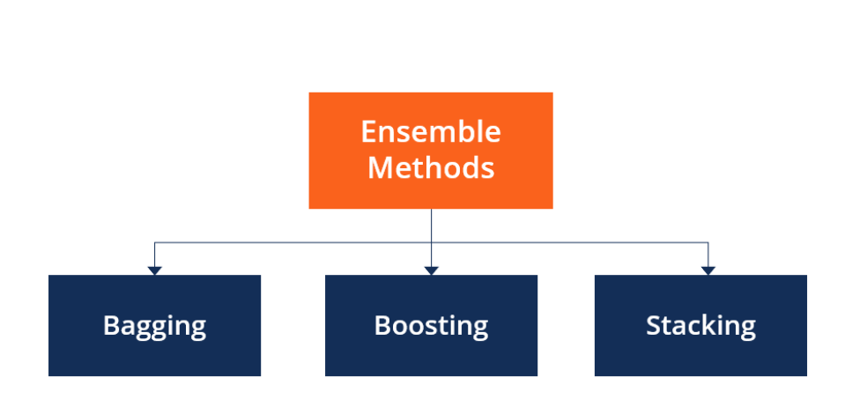
Fig (2.1 )
2.1.1 Bagging :

By using bootstrapping, bagging divides the training data into many subsets and runs distinct base models on each subset. The final forecast is typically the average or the result of a majority vote among those made by various models.

Mathematical Formula (using a majority vote to classify): Be M base models in number or each data point i, the ensemble prediction ensemble y(ensemble)​ is the mode of the predictions from the base models :

base(1),base(2),…,base(M)ybase(1)​,ybase(2)​,…,ybase(M)​ : ensemble=mode(Ybase(1),Ybase(2),…,Ybase(m))
y(ensemble) ​=mode(ybase(1)​,ybase(2)​,…,ybase(M)​)

2.1.2 Boosting:

Boosting concentrates on training base models in sequence. Each new model is trained to fix the flaws of the preceding one, giving misclassified data additional weight.

Let Dt (i) be the sample's weight i, at iteration t.
Y(ensemble​) =sign(∑t=1T​αt​ht​(x))
where T is the number of iterations, αt​ is the weight assigned to base model ht​(x)

2.1.3 Random Forest :

Random Forest is an extension of bagging where each base model is a decision tree. Additionally, it introduces randomness by selecting only a subset of features at each node split, reducing correlation among the trees.
Mathematical Formula (for classification, using majority vote):
Similar to bagging, the ensemble prediction y = ensemble is the mode of predictions from individual decision trees.

In contrast, base estimators are constructed progressively in boosting approaches, and the bias of the composite estimator is attempted to be reduced. The goal is to create a strong ensemble by combining a number of weak models.

Eg :- AdaBoost and gradient tree boosting, for instance.

Stacking

Stacking Ensemble Method called is also known as stacked generalisation. This method works by allowing a training algorithm to combine the predictions of numerous different learning algorithms that are similar. Regression, density estimations, distance learning, and classifications have all effectively used stacking. It can also be used to gauge the amount of inaccuracy that occurs when bagging

The meta-model prediction y(meta)​ is a linear combination of base model prediction,.base(1),base(2),…,base(m)ybase(1)​,ybase(2)​,…,ybase(M)​: meta=0+1base(1)+2base(2)+…+base(m)ymeta​=w0​+w1​ybase(1)​+w2​ybase(2)​+…+wM​ybase(M)​ where 0,w1,w2,…,w0​,w1​,w2​,…,wM​ are coefficients learned during training.

2.2 Decision tree :-
A machine learning method called a decision tree algorithm makes predictions by using a decision tree. It follows a decision-tree-like model of choices and potential outcomes. The data are recursively divided into subsets according to the most important attribute at each node of the tree in order for the algorithm to function.

A decision tree is used to learn from prior data and make decisions or predictions. Understanding the connections between input factors and their results and determining the key aspects that influence the choice at hand are both beneficial. decision tree's sub-section is known as a sub-tree.Pruning simply involves removing certain nodes to prevent overfitting.

2.2.2 Nodes:-

A decision tree's root node is the node from which the population first begins to branch out based on different features.

Decision Nodes: These are the nodes that result from separating the root nodes.

Leaf Nodes - Leaf nodes or terminal nodes are the nodes where further splitting is not allowed.

Because decision trees are upside down, the root is at the top and is divided into multiple nodes. In simple words, decision trees are nothing more than a collection of if-else statements. It determines whether the condition is true, and if it is, it moves on to the next node associated with that choice.

2.2.3 Entropy :-
Entropy is a physics term that refers to a measure of disorder. We can specify it more precisely as:

Entropy is a measureable physical characteristic and a scientific notion that is frequently connected to a condition of disorder, unpredictability, or uncertainty. From classical thermodynamics, where it was originally recognised, through the microscopic description of nature in statistical physics, to the fundamentals of information theory, the phrase and concept are employed in a variety of disciplines.

Entropy is measured by the formula : E = - n Σ i=1 pi log2 (pi)

2.2.4 Pruning:-

Another strategy to prevent overfitting is pruning. By removing insignificant nodes or sub-nodes, it aids in enhancing the tree's performance. Additionally, it cuts off the branches with very little significance.

Pruning can be done primarily in 2 ways:

Pre-pruning allows us to stop the tree's growth sooner. If a node's importance is low while the tree is still growing, we can trim, remove, or cut it.

After our tree has been grown to its full depth, we may begin trimming the nodes according to their importance.

2.3 Randomforest,:-

One of the most well-liked and frequently applied algorithms among data scientists is random forest. Supervised machine learning algorithms like random forest are frequently employed in classification and regression issues. On various samples, it constructs decision trees and uses their average for classification and majority vote for regression.

Leo Breiman and Adele Cutler created the flexible machine learning algorithm known as random forest. To generate predictions or classifications, it makes use of an ensemble of several decision trees. The random forest algorithm produces a consolidated and more accurate result by integrating the outputs of .

Its extensive acceptance results from its adaptability and user-friendliness, which allow it to successfully handle classification and regression issues. The method is a powerful tool for a variety of predictive tasks in machine learning because of its strength in handling complicated datasets and mitigating overfitting.

The Random Forest Algorithm's ability to handle data sets with continuous variables, as in regression, and categorical variables, as in classification, is one of its most crucial qualities. For classification and regression tasks, it performs better. In this lesson, we will examine the random forest's operation and apply it to a classification job.

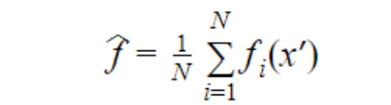

2.3.1Learning Objectives :-

*Using an example, discover how random forest functions.
* Recognise the effects of several hyperparameters in random forest
* Utilise Scikit-Learn to apply Random Forest to a classification task.

2.3.2 Working of Random Forest Algorithm :

We must first examine the ensemble learning method before we can comprehend how the random forest algorithm in machine learning functions. Ensemble is just the fusion of several models. As a result, a group of models rather than a single model is employed to create predictions.

Ensemble employs two categories of techniques:

2.3.3. .Bagging: The final result is based on majority voting and a different training subset is created using replacement from sample training data. Consider Random Forest.

Random forest employs bagging, also referred to as bootstrap aggregation. A random sample or random subset is selected via bagging from the complete data set. As a result, each model is created using the samples (Bootstrap Samples) that the Original Data gave, with a replacement process known as row sampling. Bootstrap refers to this stage of row sampling with replacement. Currently, each model is trained separately, producing results. After merging the outputs of all the models, the final decision is made based on a majority vote. Aggregation is the process of aggregating all the results and producing a result based on a majority vote.

2.3.3 Boosting—By building sequential models with the maximum accuracy possible, this technique turns weak learners become strong ones. Take ADA BOOST and XG BOOST, for instance.

One method that makes use of the idea of ensemble learning is boosting. A boosting method creates the final result by combining several straightforward models, commonly referred to as weak learners or base estimators. It is accomplished by using weak models in series to develop a model.

There are various boosting algorithms; AdaBoost was the first one created specifically for binary classification that was truly successful. The term "AdaBoost" stands for "Adaptive Boosting," which is a popular boosting method that combines several "weak classifiers" into one "strong classifier." There are further boosting methods.

2.3.4 Steps of Random Forest Algorithm

Step 1 : In the Random Forest model, each decision tree is constructed using a subset of data points and a subset of features. Simply simply, m features and n randomly chosen records are obtained from a data set with k records.

Step 2: For each sample, a unique decision tree is built.

Step 3: An output will be produced by each decision tree.

Step 4: For classification and regression, the final result is evaluated using the majority vote or averaging

2.4 Encoding :

- Represent a character encoding

- public abstract class Encoding : ICloneable

The process of converting a group of Unicode characters into a series of bytes is known as encoding. Decoding, on the other hand, entails turning a series of encoded bytes into a collection of Unicode characters. See Character Encoding in.NET for details on the Unicode Transformation Formats (UTFs) and other encodings supported by Encoding.

It should be noted that Encoding is designed to work with Unicode characters rather than random binary data, like byte arrays. You should utilize a protocol like uuencode, which is implemented by methods like Convert. To Base 64Char Array, if you need to convert any binary data into text.

2.4.1 Depending on the type of data conversion :

The data encoding technique is split into the following categories.

The modulation methods of analogue signals, such as amplitude modulation, frequency modulation, and phase modulation, fall into this category.

Pulse Code Modulation PCM is used to convert analogue data into digital signals, a process known as digitization. Therefore, it is simply digital modulation. The key elements in this are sampling and quantization, as we've just covered. Compared to PCM, delta modulation produces better results.

Digital signals to analogue data This category includes modulation methods like Amplitude Shift Keying (ASK), Frequency Shift Keying (FSK), Phase Shift Keying (PSK), etc. These will be discussed in subsequent chapters.

Digital signals to digital data These can be found in this area. There are various methods for converting digital data into digital signals.

2.4.2 Encoding Methodologies

- Label encoding :

In label encoding, we assign a label or a number to each category. There is no connection between the categories' labels. As a result, after encoding, categories with connections or proximity to one another lose this information.

- Frequency encoding:

It is a method of using the labels for the categories' frequency. Depending on the nature of the data, it allows the model to interpret and assign weights in direct and inverse proportion when the frequency is somewhat correlated with the goal variable.

- One – hot encoding :-

With this approach, we map each category to a vector that includes the numbers 1 and 0, which indicate whether the feature is present or not. The quantity of vectors is determined by the categories we wish to preserve. This technique generates a large number of columns for features with high cardinality, which greatly delays learning. There is discussion on when to utilise one hot encoding versus dummy encoding. They are very similar except that dummy creating creates one fewer column than hot encoding, which produces the same amount of columns as categories. The modeller should ultimately handle this appropriately during the validation process.

2.4.3 Encoding Statistics :-
The term "encoding variability" refers to the diversity in individual encoding within a category. When we discuss the variability of a single hot encoding, the variability is dependent on the point in implementation at which it chooses the number of categories to include that have an adequate impact on the objective. Other encoding techniques do exhibit a sizable degree of variability, which is noted during validation.

We count the labels for the categories and then compute the standard deviation of the labels to get the Encoding distinguishability. This demonstrates the distinguishability of the encoded categories, which are either dispersed or concentrated in a particular area For a better understanding of how the model is biassed, please see this discussion. For various models, you must estimate your encoding strategy, for example, you can use mean target encoding for regression. You can choose relative frequency encoding if you have the categorization.

Finally, present a transformer in the scikit-learn style that aids in encoding categorical variables in various ways.

2.5 Iogistic Regression :-

Predictive analytics and categorization frequently make use of this kind of statistical model, also referred to as a logit model. Based on a given dataset of independent variables, logistic regression calculates the likelihood that an event will occur, such as voting or not voting.

It is possible to predict a binary outcome, such as yes or no, using the statistical analysis technique known as logistic regression. A logistic regression model makes predictions about a dependent data variable by investigating the correlation between one or more independent variables that are already present.

The following presumptions concerning logistic regression must be understood before we begin its implementation:

When using binary logistic regression, the outcome of interest is represented by factor level 1 and the target variables are required to always be binary.

The independent variables in the model must be independent of one another in order to prevent multi-collinearity. Our model must contain relevant variables. For logistic regression, a high sample size is recommended.

When used for classification, the linear regression model does not perform well. How come? If there are two classes, you may use linear regression and label one class as 0 and the other as 1. Technically, it's correct, and the majority of linear model software will generate weights for you. However, there are a couple issues with this strategy:

Although a linear model does not produce probabilities, it treats the classes as numbers (0 and 1) and fits the hyperplane that minimises the distances between the points and the hyperplane (with a single feature, this is usually a line). Therefore, you cannot understand it as probabilities; it is merely an interpolation between the points. Additionally, a linear

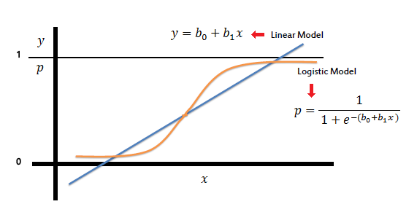
Fig (2.5)

model extrapolates and provides you with numbers below 0 and above 1. This is encouraging evidence that classification might be done more intelligently.

There is no meaningful threshold at which you can separate one class from the other because the anticipated outcome is a linear interpolation between points rather than a probability. On Stackoverflow, this problem has been well shown.

Multiple-class classification issues do not lend themselves to linear models. The following class would need to be labelled with 2, then 3, and so on. The linear model would impose an odd structure on the link between the features and your class predictions even if the classes might not have any meaningful order.

Even though classes that receive a similar number are not more similar than other classes, the greater the value of a feature with a positive weight, the more it contributes to the prediction of a class with a higher number.

The size of a linear model categorises tumours as benign (0) or malignant (1). The lines display the linear model's forecast. We can use 0.5 as the categorization criterion for the data on the left. A threshold of 0.5 no longer distinguishes the classes after adding a few additional instances of malignant tumours. The jittering of the points helps to prevent over-plotting.

A statistical analysis method called logistic regression uses previous observations from a data set to predict a binary outcome, such as yes or no.

By examining the correlation between one or more already present independent variables, a logistic regression model forecasts a dependent data variable. A logistic regression could be used, for instance, to forecast whether a candidate for office will win or lose, or if a high school student will be accepted into a particular institution or not. These simple choices between two options allow for binary outcomes.

Multiple criteria for input can be taken into account using a logistic regression model. The logistic function can take into account the student's grade point average, SAT score, and number of extracurricular activities in the case of college acceptance. It then rates new cases according to their likelihood of falling into one of two outcome categories based on historical information about past outcomes involving the same input criteria.

The technique of logistic regression has grown in significance in the field of machine learning. It enables machine learning algorithms to categorise incoming data based on previous data. The algorithms get more accurate at predicting classes within data sets when new pertinent data is added. By enabling data sets to be staged for analysis during the extract, transform, and load process by placing them into certain predetermined buckets, logistic regression can also be used in data preparation tasks.

Formula logistic(η)=1/1+exp(−η)

2.5.1 Types of logistic Regression :-

Although it can predict two more types of target variables, logistic regression often refers to binary logistic regression with binary target variables. Those many criteria allow for the following categorization of logistic regression.

- Binomial or binary
In this style of categorization, a dependent variable will only have the types 1 or 0 as potential values. These variables can, for instance, stand for victory or defeat, yes or no, etc.

- Multinomial
The dependent variable in this sort of classification can have three or more alternative unordered types or the types with no quantitative significance. These variables could, for instance, stand in for "Type (“A” or "B" or " C").

- Ordinal
The dependent variable in this sort of classification can have three or more possible ordered categories or the types that are statistically significant. For instance, these variables could stand for "poor" or "good," "very good," or "excellent," with scores of 0, 1, 2, or 3.

2.5.2 logistic regression serve

The mathematics for calculating the influence of many variables (such as age, gender, and ad placement) with a certain result (such as click-through or ignore) is simplified by the use of logistic regression. The generated models can be used to dissect the relative efficacy of various interventions for distinct population subgroups, such as young versus old or male versus female.

Additionally, logistic models can modify raw data streams to produce characteristics for various AI and machine learning methods. In reality, one of the often employed machine learning techniques for binary classification issues, or problems with two class values, includes logistic regression. These problems include predictions like "this or that," "yes or no," and "A or B."

In addition to estimating event probabilities, logistic regression may also establish a link between feature and outcome probabilities. In other words, it can be applied to categorization by building a model that links the number of hours of study to the likelihood that a student would pass or fail. On the other hand, if the number of study hours is given as a feature and the response variable has two possible values—pass or fail—the same model might be used to predict whether a specific student will pass or fail.

Binary Logistic Regression model:

Binary or binomial logistic regression, in which the objective or dependent variable can only have one of two potential types—1 or 0—is the most basic type of logistic regression. It enables us to simulate the link between a binary or binomial target variable and a number of predictor variables. The linear function is essentially used as an input to another function, such as g, in logistic regression.

hθ (x) = g(θ*x, x) where 0 ≤ hθ ≤ 1

If all of the predictors are continuous, discriminant function analysis would be used with a categorical dependent variable. However, if the predictors are a mixture of continuous and categorical variables, logistic regression is favored to discriminant analysis. There are no presumptions made by logistic regression regarding the distributions of the predictor variables. This method has grown particularly well-liked in medical research where the dependent variable is whether a patient has an illness or not.
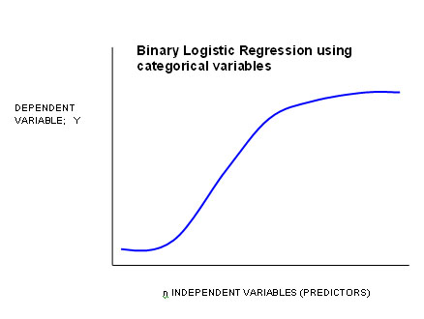

Fig (2.5.3)

    - Logistic Regression (aka logit, MaxEnt) classifier.

In the event of many classes, the training method employs the one-vs-rest (OvR) scheme if the'multi_class' option is set to 'ovr' and the cross-entropy loss if the'multi_class' option is set to'multinomial'. (At this time, only the solvers 'lbfgs','sag','saga', and 'newton-cg' offer the'multinomial' option.)

This class uses the 'liblinear' library, the 'newton-cg','sag','saga', and 'lbfgs' solvers to implement regularised logistic regression. Keep in mind that regularisation is used by default. Both dense and sparse input can be handled by it. For best results, use C-ordered arrays or CSR matrices with 64-bit floats; all other input formats will be transformed (and copied).

    - Logistic Regression Advantages and Disadvantages:
The logistic regression model has many of the advantages and disadvantages of the linear regression model. Although many individuals have used logistic regression extensively, it struggles with its limited expressiveness (for example, interactions must be inserted manually) and other models may perform more accurately in terms of prediction.

The interpretation of the weights in the logistic regression model is more challenging because they are multiplicative rather than additive, which is another drawback.

Complete separation can be detrimental to logistic regression. The logistic regression model is no longer able to be trained if there is a feature that would perfectly distinguish the two classes. Because the ideal weight would be unlimited, the weight for that feature would not converge. This is terrible because using such a feature would be quite beneficial. But if you already have a straightforward rule that divides the two classes, you do not require machine learning. By creating a prior probability distribution of weights or penalising the weights, the problem of complete separation can be resolved.

Odds ratios are obtained using logistic regression when there are multiple explanatory variables. With the exception of the response variable being a binomial, the process is relatively similar to multiple linear regression. The effect of each variable on the chances ratio of the observed important event is the outcome. The key benefit is that by looking at how all of the variables are related, confounding effects can be avoided. In order to make the logistic regression process as clear as possible, we use examples in this article to describe it. The fundamental interpretation of the results is highlighted after the technique definition.

Because it reduces complicated probability calculations to simple arithmetic problems, logistic regression is crucial. Although the computation itself is admittedly somewhat complicated, most of the tedious work is automated by contemporary statistical software. This helps to significantly reduce the impact of confounding factors and considerably simplifies analysing the impact of various variables.

As a result, statisticians can study and predict many elements' contributions to a certain outcome fast.

    - Key factor of logistic regression :

When utilising logistic regression, statisticians and citizen data scientists need to be aware of a few assumptions. The variables must initially be independent of one another. Zip code and gender, for instance, might be combined in a model, but zip code and state would not.

When using logistic regression as a starting point for intricate machine learning and data science applications, other less visible associations between variables could get lost in the noise. For instance, data scientists might put a lot of effort into making sure that the algorithm does not incorporate variables like Salary wages and Income ratio that are linked to increasing wages. However, these can occasionally be incorporated into the algorithm inadvertently through variables that weren't initially believed to be connected, like zip code. The relationship between the variables and the result must also be able to be linearly related via logarithmic odds, which is a little more flexible than a linear relationship. A high sample size is also necessary for logistic regression.

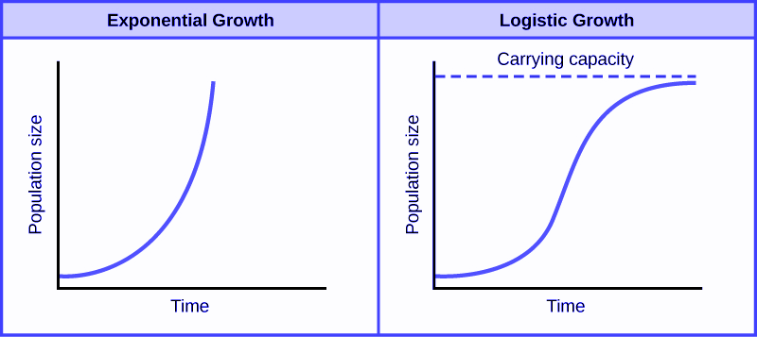

Fig (2.5.6)

When e is the exponential constant, x θ is the midway value of x, L is the highest value of y (also known as the "carrying capacity"), and k is the steepest gradient of the curve.
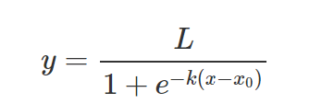

2.5.7 Difference Between logistic and linear regression

The primary distinction between logistic and linear regression is that the output of logistic regression is constant whereas the output of linear regression is continuous.

The outcome, or dependent variable, in logistic regression has just two possible values. However, the output of a linear regression is continuous, which means that there are an endless number of possible values for it.

When the response variable is categorical, such as yes/no, true/false, and pass/fail, logistic regression is utilised. When the response variable is continuous, like hours, height, or weight, linear regression is utilised.

Logistic regression and linear regression, for instance, can predict various outcomes depending on the information about the wages of employ, the experience level of employ , Education of employ result.

Predictions using logistic regression are limited to certain values or categories. Logistic regression can therefore predict whether a pupil will succeed or fail. The Employ salary increasing precent on a scale of 0 to 100 can be predicted by linear regression because its predictions are continuous, such as numbers in a range.

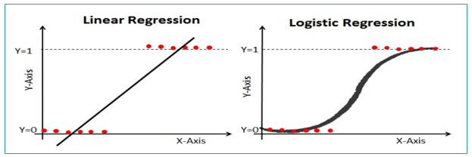

Fig(2.5.7)

For example, if you want to forecast the price of a piece of property based on its square footage, you can use linear regression. The regression line is a straight line in this situation. Contrarily, classification problems are solved using logistic regression, which forecasts the likelihood that a dependent variable, Y, will take the value 1, given the values of the predictors. The regression curve in binary logistic regression is a sigmoid curve.

  - K- Fold

2.6.1 K- fold cross validation :

K-fold The dataset is divided into a K number of folds during cross-validation, which assesses the model's performance when faced with fresh data. K is the number of groups into which the data sample is divided. For instance, we can refer to this as a 5-fold cross-validation if the k-value is 5. At some stage during the procedure, each fold serves as a testing set.

2.6.2 K fold cross validation process: -

Pick your k-value. The dataset should be divided into k folds.
Use your k-1 fold as the training dataset first, and the remaining folds as the test dataset. Validate the model on the test dataset after training it on the training dataset. Save the verification result. Replicate steps 3 through 5, but alter the k test dataset value. As a result, we selected k-1 as our test dataset for the first round before moving on to k-2 for the second. By the time it was over, you would have verified the model on all of your folds. To gauge the model's skill, average the outcomes from production.

2.6.3 k fold cross validation random forest:-

Cross validation is used to evaluate, contrast, and choose the best model. Cross-validation is utilised with three models: Random Forest, Logistic Regression, and Decision Trees. Random Forest is chosen to generate the final model since it has taken the best average score from the process.

2.6.4 k fold cross validation decision tree

Additionally, decision trees' hyperparameters can be adjusted using cross-validation. Hyperparameters are variables that are selected by the user prior to training the model rather than ones that are learned from the data. Hyperparameters for decision trees include the maximum tree depth, the minimal sample size needed to divide an internal node, and the minimal sample size needed to be at a leaf node. Scikit-learn's GridSearchCV function can be used to cross-validate the hyperparameters of a decision tree. This function runs a grid search over all possible combinations of hyperparameters using a model, a collection of hyperparameters to search over, and a scoring metric.

2.6.5 K fold cross validation logistic regression :

Predictive model evaluation can be done using the K-fold cross-validation method. The dataset is split into k folds or subsets. A new fold is used as the validation set each time when the model is trained and assessed k times. In order to calculate the generalisation performance of the model, performance measures from each fold are averaged.

Throughout the entire procedure, training and testing would be executed precisely once for each set (fold). It aids in preventing overfitting. We are aware that the best performance accuracy is achieved when a model is trained using all of the data in a single brief run. We can design a generalised model by avoiding this k-fold cross-validation. Due to the magnitude of the data, we must divide the data set into three sets: training, testing, and validation, in order to complete the K-Fold Cross Validation.

2.6.6 K fold cross validation encoding :-

By adding a regularisation to the mean encoding, k-fold target encoding essentially aims to reduce overfitting in mean-target encoding. a selection of the test and train datasets.

When a feature only contains a small number of categorical variables, ne-hot encoding or dummy encoding is a reliable technique. However, if the feature contains more categorical variables, the dataset's dimension will inevitably expand, making it less valuable. Additionally, because the label-encoding assigns features a random order, it has its limitations. Additionally, there is no connection between the target and label encoding.

2.7 Data Exploration:

2.7.1 Histograms and Distributions: Visualize the distribution of salary data and other relevant features to understand their characteristics.

Box Plots: Use box plots to identify outliers and assess the spread of salary data within different categories (e.g., education level, job roles).

Scatter Plots: Explore the relationships between numerical features like years of experience and salary.

2. Model Performance:

Learning Curves: Plot learning curves to visualize how model performance (e.g., MAE, MSE) changes as the training set size increases. This can help assess bias and variance.

Validation Curves: Vary hyperparameters (e.g., tree depth, number of trees) and plot how they impact model performance.

ROC Curves and Precision-Recall Curves: If you're doing classification with Logistic Regression, plot these curves to assess model classification performance.

3. Feature Importance:

Bar Plots: Visualize feature importance scores for Decision Trees and Random Forest. This can help you identify which features contribute the most to salary predictions.

4. Model Comparison:

Bar Charts: Compare the performance metrics (e.g., MAE, MSE) of Logistic Regression, Decision Trees, and Random Forest in a bar chart to highlight their differences.

5. Model Interpretability:
Decision Tree Visualization: If the decision tree is small and interpretable, you can visualize it to understand the decision-making process.

6. Predictions vs. Actuals:
Actual vs. Predicted Scatter Plot: Plot actual salary values against predicted values to assess how closely the model predictions align with the ground truth.

7. Residual Analysis:

Residual Plot: For regression tasks, plot the residuals (the differences between actual and predicted values) to check if they are randomly distributed and have constant variance.
8. Cross-Validation:

Cross-Validation Plot: Visualize the results of cross-validation, such as mean squared error or mean absolute error, to assess model robustness.

9. Ensemble Methods :

Comparing Feature Importance: To understand model consensus while using Random Forest, you can compare feature importance between different trees in the forest.
Keep in mind that the visualization you choose will rely on the precise insights you want to get and the characteristics of your data. Visualizations are crucial for efficiently communicating data and spotting trends or problems in your salary prediction project. These plots and visualizations can also be made using Python libraries like Plotly, Seaborn, and Matplotlib.

Section 3:-

3.1 Logistic regression in ensemble methods Salary prediction Experimental

a dataset that includes each person's yearly income as a result of many circumstances. It also depends on a number of other things, including a person's age, gender, occupation, and degree of education.

The target field in the 16-column dataset is income, which is separated into two classes: =50K and >50K. Based on the person's personal information, we can investigate the feasibility of forecasting their income level.

It was possible to locate the "adult" dataset in the M.L Repository.

The Adult Income data set is being used in this study to investigate logistic regression. Based on the information provided, we will attempt to predict a person's salary class, This comes from a ensemble methods .

The coloured portion represents a percentage. This graphic shows that between the ages of 30 and 50, the proportion of those making over $50,000 peaks at about 35%.

We will then plot of the number of hours people work each week.

It is evident from the graph above that 40 hours is the maximum number of hours worked per week.

Now we will show the income brackets according to the geographic area that they reside in.However, we must first rename the nation column to region.

It displays the output listed below. From the above output it is clear that people from adult data-set have the highest income, where around 11000 people earn more than 50k and people around 30000 earn less than or equal to 50000.

This model's goal is to divide people into two income groups: those making under $50,000 and those making over $50,000. Using training data, we will create the model, and test data, we will use to forecast the wage class.

The glm() function, which instructs to run a generalised logistics regression model, was used to train our model. "income." indicates that we want to model income with all of the features that are accessible. We use family = logistics regression () since our prediction is either below 50k or over 50k.

Making predictions as illustrated using the trained data.

3.1.1 Experimental analysis :

Instead of regression tasks like forecasting salaries, logistic regression is more frequently employed for binary classification problems. However, you may think about utilising different regression algorithms or ensemble methods like Random Forest or Gradient Boosting for better outcomes if you're interested in employing ensemble methods to forecast salaries and carrying out an experimental analysis. Here's how you could go about it:

3.1.2. Data gathering and preparation:

Amass a dataset with characteristics that can be used to forecast salaries, such as years of experience, work role, and level of schooling.
Data cleaning, handling of missing values and outliers, and data quality assurance.
Use methods like label encoding or one-hot encoding to encode categorical information.

3.1.2. Splitting data:

Create training, validation, and test sets from the dataset.

3.1.3. Ensemble Salary Prediction Methods:

For regression problems like salary prediction, think about employing ensemble approaches like Random Forest or Gradient Boosting rather than Logistic Regression.
Create and refine an ensemble model by using a Python package like scikit-learn.

3.1.4. Model Assessment:

Regression metrics like MAE, MSE, and RMSE should be used on the validation set to assess the performance of the ensemble model.
Adjust hyperparameters such as the number of trees, tree depth, learning rate, etc.

3.1.5. Observational Analysis:

Try different experiments to learn more:
To determine which ensemble approach performs best for your particular salary prediction task, compare them (for example, Random Forest vs. Gradient Boosting).
Investigate the effects of the ensemble models' hyperparameters on performance.
Analysing the value of features Recognise the features that, in the context of ensemble models, most significantly influence pay projections.

3.1.6. Comparison of Models

Consider turning the task into a classification problem, such as determining whether a wage is over or below a certain threshold, if you're interested in comparing with Logistic Regression. In this situation, you may train a classification-based logistic regression model.

3.1.7. Interpretability:

Even if simple models like Logistic Regression are easier to read than ensemble approaches, you can still analyse feature importance and comprehend how the ensemble is making predictions.

3.1.8. Ethical Points to Consider

Always act morally when handling private information about salaries.

Keep meticulous records of your experimental design, procedures, findings, and conclusions.
Keep in mind that the algorithm you use will depend on the type of data you have and the particular issue you're trying to solve. While ensemble techniques are frequently successful for difficult regression tasks, logistic regression may not be the best option for predicting salaries.

3.1.2.1 The result is as follows:

The demonstrates that 70% of the data from Train were accurate.

based on the test results displayed here, make predictions.

The Adult Income data set is being used in this study to investigate logistic regression. Based on the information provided, we will attempt to predict a person's salary class. This is from a project that was given to us using ensamble procedures.

3.1.2.10. Testing Data :-
utilising our logistic regression model on the test data. To obtain projected probabilities rather than probabilities on the logit scale, we had to set type = "response" above. Here, accuracy appears to be 70%.

Our forecasts are probabilities; we state that probabilities more than or equal to 50% will be TRUE above 50K and that probabilities less than 50% will be FALSE below 50K.

3.2. Random Forest in ensemble methods Salary prediction Experimental

It appears that you are considering using Random Forest as an ensemble method to estimate salaries and possibly carrying out an experimental analysis. As a result of its proficiency in handling intricate data linkages, Random Forest is a well-liked algorithm for both classification and regression problems. You can use it to forecast compensation values based on a variety of personal characteristics or characteristics of individuals in the context of salary prediction.

3.2.1 General plan of Problem for this situation:

3.2.1.1. Data gathering and preparation:

Amass a dataset with information that is important for estimating salaries, such as job title, location, years of experience, and education level.
By addressing missing values, outliers, and maintaining data quality, clean the data.
Use methods like label encoding or one-hot encoding to encode categorical information.

3.2.1.2.Splitting data:

Create training, validation, and test sets from your dataset. The test set will be used to assess the performance of the final model, the validation set to fine-tune hyperparameters, and the training set to train the model.

3.2.1.3 the Random Forest Model

Utilise a Python library like scikit-learn to create a Random Forest model. This entails building a collection of decision trees.

Utilise the training data to train the model.

Optimise performance by adjusting hyperparameters like the number of trees, depth of trees, and other settings. For this, methods like grid search and random search can be used.

3.2.1.4. Model Assessment:

Utilise the proper metrics for regression tasks to assess the model's performance. The Mean Absolute Error (MAE), Mean Squared Error (MSE), and Root Mean Squared Error (RMSE) are common metrics.
To optimise your model and choose the optimum hyperparameters, use the validation set.

3.2.2. Observational Analysis:

The indicated using an experimental approach, you might want to consider the following:
Effect of feature choice: Try out several subsets of attributes to determine which ones affect salary prediction the most.
contrasting models To determine which regression model works best for your particular assignment, compare the Random Forest model to others like Linear Regression, Support Vector Regression, or Gradient Boosting.
Impact of ensemble size: Examine the impact of the Random Forest's tree density on the model's performance

3.2.3. Interpretation:

Due of their intricacy, Random Forest models are not the easiest to understand. If you want to know which attributes the model uses to make predictions, you may investigate methods like feature importance analysis.
Bear in mind that performing experiments necessitates a methodical approach that includes suitable statistical analysis, control over variables, and transparent documentation of your process and outcomes.

while handling private information like salary information and adhere to all applicable laws.

3. Decision tree in ensemble methods Salary prediction Experimental

Certainly! The cornerstones of ensemble techniques like Random Forests are decision trees. For autonomous tasks like wage prediction, they can also be used. Here's how you could go about utilising a Decision Tree to estimate salaries and carrying out an experimental analysis:

3.1.1 Data gathering and preparation:

Gather data on factors that are important for predicting salaries, such as years of experience, work role, and degree of education.

Data cleaning, handling of missing values and outliers, and data quality assurance.
Use methods like label encoding or one-hot encoding to encode categorical information.

3.1.2 Splitting data:

Create training, validation, and test sets from the dataset.

3.1.3 Model of a Decision Tree:

Utilise a Python library like scikit-learn to create a Decision Tree model.

Utilise the training data to train the model.

3.1.4. Model Assessment:

Regression metrics like MAE, MSE, and RMSE should be used to assess the model's performance on the validation set.

To improve performance, tweak hyperparameters like the tree's maximum depth.

3.1.5. Observational Analysis:

Experiments to learn more:

Depth of the tree: Try out various decision tree depths to see how they effect the model's performance. Although a deeper tree may be able to depict more intricate relationships, it may also result in overfitting.

Implement pruning strategies to avoid overfitting, and evaluate how they affect the effectiveness of the model.

Feature significance Consider feature importance analysis to determine which characteristics have the greatest impact on salary forecasts.

3.1.6. Comparison of Models

Examine the Decision Tree model's performance in comparison to other regression models, such as ensemble techniques like Random Forest and other standalone models like Linear Regression or Support Vector Regression.

7. Interpretation:
In comparison to Random Forests, Decision Trees are easier to read. To comprehend how the decision tree generates predictions, visualise its structure.

3.1.8. Ethical Points to Consider

Make sure you handle sensitive salary data ethically and in accordance with privacy laws.

Keep meticulous records of your experimental design, procedures, findings, and conclusions.
Keep in mind that decision trees are prone to overfitting the training set, which results in poor generalisation to fresh data. To address this problem, experiment with hyperparameters and methods, then use the validation set to improve your model. You can get to significant conclusions about the performance and behaviour of the model by carrying out experiments methodically and critically evaluating the outcomes.

4. Logistic Regression, Random Forest, Decision tree in ensemble methods Salary prediction Experimental

Certainly, Employing Logistic Regression, Decision Trees, and Random Forest as an ensemble approach for predicting salaries, doing an experimental analysis, and contrasting their differences.

4.1.1. Data gathering and preparation:

The salary prediction dataset should be collected and prepared, including managing missing values and encoding categorical factors.

4.1.2. Splitting data:

Create training, validation, and test sets from the dataset.

4.2.1. Logistic Regression

You may turn the process of predicting salaries into a classification problem by using Logistic Regression, which is often used to determine if a wage is above or below a given threshold.

Utilise the training set of data to create a Logistic Regression model.

Use the validation set to adjust hyperparameters, such as regularisation strength.

4.3.1. Decision Tree:

Utilise the training data to create a Decision Tree model for regression.

To avoid overfitting, experiment with various tree depths and do pruning.

Analyse the validation set's performance with the model.

4.4.1. Random Forest

Create an ensemble Random Forest model using the training data.
Try with other hyperparameters, such as the quantity of trees and the maximum depth of trees.

Analyse the validation set's performance with the model.

4.1.6. Experimental Evaluation:

To explore the differences between the models, conduct experiments:
To determine whether model is more effective in forecasting salaries, compare performance measures we use accuracy scores for each model on the validation set.

Utilising the test set, gauge the generalisation of the model.

Determine which features have the greatest impact on salary forecasts by analysing the importance of each feature for Decision Trees and Random Forest.
For each model, run experiments with various hyperparameters to determine the best setting.

4.1.7. Comparison and Dissimilarities

Type of Algorithm:

Binary classification technique called logistic regression is useful for predicting categories like "high salary" or "low salary."

Decision Tree: Creates a tree-like structure for decision-making and is used for both classification and regression.

Random Forest: A group of Decision Trees that work together to enhance performance and minimise overfitting.

4.1.8 Interpretability:

Coefficients in a logistic regression are simple to understand and show how features affect the prediction.

The decision tree's branching logic makes it comprehensible.

It ensemble structure, Random Forest is less interpretable, however its feature importance can be examined.

4.1.9 Overfitting and Complexity:

Simple model, logistic regression, can perform poorly in nonlinear connections.

Decision Tree: If not pruned appropriately, prone to overfitting.

Random Forest: Through ensemble averaging, it lessens overfitting.

Performance: When features and the target have linear relationships, logistic regression may perform well. Decision trees: They may overfit yet they can capture intricate relationships. Random Forest: Because of the ensemble effect and less overfitting, it frequently performs well.

Tuning:
Regularisation strength is an important hyperparameter in logistic regression.
Decision Tree: Model complexity is influenced by the depth and pruning settings.
Random Forest: Tree depth and tree count are more important.

A logistic regression model stratified by smoking of the risk of cardiovascular events over the course of one's lifetime. Plotted fitted lines on the probability scale (B) and log-odds scale (A). When no polynomials or splines are used in the regression, the lines are straight.

Results:
When logistic regression is used we are getting an accuracy of percent. 0.8037770612620913

When random forest is used we try to fine tune depth and number of folds used on Data As K folds cross validation is applied on data we try to find best number of K folds

When random forest is applied we are trying to fine tune three hyper parameters:

- Depth of a tree
- Number of folds that can be used for K Cross Validation
- Number of trees in random forests

For hyper tuning depth parameters we used range of depth from 2 to 25 and the value that gives best accuracy is hyper tuned we use % decision trees as base condition when trying to hyper tune parameters.

For hyper tuning folds parameters we used range of K from 2 to 15 and the values that gives best accuracy is taken and the value is taken and hyper tuned here also we take d5 decision trees as base condition

When hyper tuning for number of decision trees as we already have best number of folds and best depth after hyper tuned we use number of decision trees in random forests to be hyper tuned.
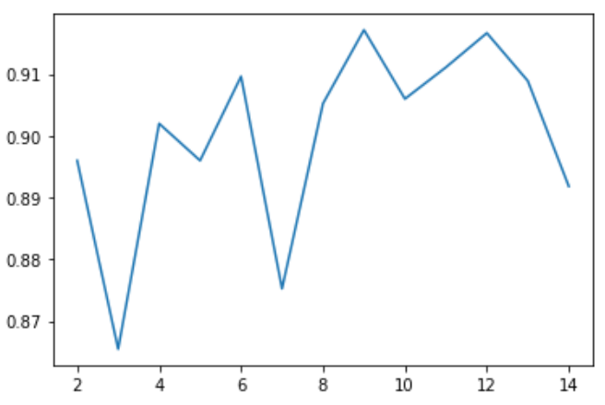
The plot between number of folds and accuracy score to find best number of folds and hyper tuned fold value is 10 here X axis is number of folds and y axis is accuracy score.

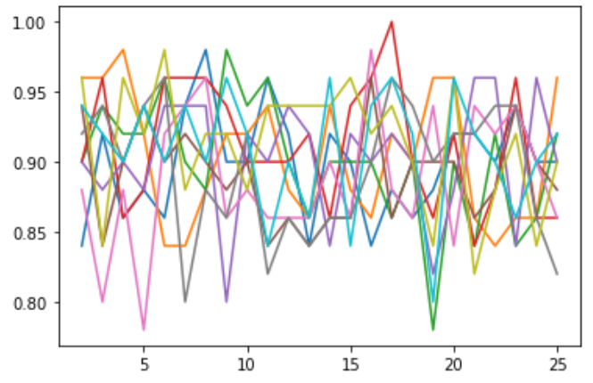
The above is the plot for tree depth and accuracy scores to find best tree depth where you can get best accuracy by fine tuning best tree depth hyper tuned depth value is 9 here X axis is tree depth and Y axis is accuracy scores

The below plot is between number of decision tree and accuracy scores to find best number of decision trees in random forests are hyper tuned to get best accuracy by plotting.
And number of decision trees for a random forest which gives high accuracy score is hyper tuned.

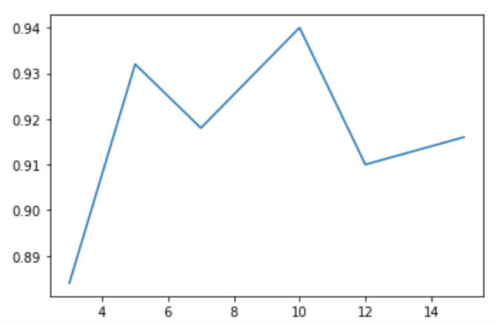

Number of decision trees taken are [3,5,7,10,12,15] and accuracy scores calculated are [0.884, 0.9319999999999998, 0.9179999999999999, 0.9399999999999998, 0.9099999999999999, 0.9160000000000001]
So the number of decision trees hyper tuned for random forest are 10.

The accuracy score for a single decision tree where best number of k folds bestk and best tree depth best d which are calculated before for random forests is used and the average accuracy score value is 0.9040000000000001

Conclusion of the Project:

The purpose of this project was to construct a reliable salary prediction model and assess its performance using a variety of machine learning approaches, such as Logistic Regression, Decision Trees, and Random Forest. We have learned important things about the advantages and disadvantages of each strategy in the context of wage prediction through a methodical experimental approach.

4. Overview of the experiment:

In order to estimate salaries, we started by gathering and preprocessing a large dataset with factors including education level, years of experience, job function, and geography. In order to simplify unbiased model evaluation, we next divided the dataset into training, validation, and test sets.

We converted the pay prediction task into a binary classification issue using logistic regression, predicting whether salaries are above or below a specific threshold. For direct regression, decision trees and random forests were used. To enhance model performance, cross-validation, feature importance analysis, and hyperparameter adjustment were used.

4.1 Self-Assessment:

Throughout this research, we have polished our abilities in experimental design, model construction, and data preprocessing. In the area of salary prediction, we got experience in choosing suitable machine learning algorithms for regression tasks and classification tasks. We also gained expertise in adjusting hyperparameters to optimize model performance. Furthermore, we learned how interpretable certain models are, with Logistic Regression being particularly interpretable and Decision Trees and Random Forests offering feature importance analysis.

On the downside, we encountered challenges related to overfitting when using Decision Trees, which required careful pruning and depth selection. Moreover, the ensemble methods (Random Forest) consistently outperformed Logistic Regression in terms of prediction accuracy, suggesting that for this specific salary prediction task, regression methods might be more suitable than classification.

Strengths:
Ensemble Robustness: The ensemble methods, especially Random Forest, demonstrated resilience against overfitting, making them suitable for complex datasets.

Predictive Power: Random Forest consistently outperformed Logistic Regression and Decision Trees, indicating its potential for accurate salary prediction.

Weaknesses:
Interpretability: The ensemble methods are less interpretable compared to Logistic Regression, which could be a drawback in scenarios where model explanations are critical.

Complexity:
Random Forest can be computationally expensive and may not be the best choice for real-time predictions.

Threats:

Data Privacy Threats:
The project's reliance on salary data poses risks of data breaches and privacy violations, highlighting the need for robust security measures.

Model Bias:
If the dataset is not representative, models could learn biased patterns, leading to unfair predictions.

Model Overfitting:
Despite efforts to prevent overfitting, Decision Trees can still overfit to the training data, leading to poor generalization.

In conclusion, this salary prediction project using ensemble methods presents several professional challenges related to ethics, fairness, and legal compliance. Further research in explainable AI and feature engineering could enhance the project's applicability. While ensemble methods exhibit strengths in terms of predictive power, they also come with complexities and interpretability issues that need to be carefully considered. Threats include data privacy concerns and the risk of model bias. Addressing these issues is essential to ensure the responsible and effective use of machine learning in salary prediction.

5 Professional Issues:

In this project, we encountered several professional issues. Ethical considerations were paramount when handling salary data, as maintaining data privacy and adhering to legal guidelines were essential. Data preprocessing also posed challenges, such as dealing with missing values and ensuring data quality, highlighting the importance of data ethics and data stewardship in real-world applications.

We also encountered issues with model interpretability, particularly when using ensemble techniques like Random Forest, which are intrinsically harder to understand than Logistic Regression. This emphasizes the need for real-world initiatives to balance model accuracy and interpretability, especially when the outcomes affect crucial decisions.

As a result, this effort shed light on the potential of ensemble techniques, particularly Random Forest, for jobs involving wage prediction. We developed our data science expertise, realized the value of ethical considerations, and learned more about the trade-offs between model interpretability and prediction accuracy, all of which are important lessons for the future.

Ethical dilemmas:
Maintaining data privacy and confidentiality is essential while handling wage information. Strong data anonymization and adherence to ethical standards are required due to the possibility of disclosing private information about people's incomes.

Fairness and Bias:
Discriminatory outcomes may result from biased model predictions or biased datasets. To avoid maintaining socioeconomic and gender inequities, it is essential to ensure fairness in wage prediction models.

Data stewardship:
Maintaining data integrity and quality at all stages of a project's lifecycle is a continuing professional duty. Taking care of missing data, guaranteeing data consistency, and documenting data transformations are all included in this.

Legal Compliance:
To prevent legal penalties associated to processing individual wage information, compliance with data protection laws, like GDPR, HIPAA, or local privacy laws, is essential.

Data Privacy and Ethics:

Issue: Handling salary data involves sensitive personal information, raising ethical concerns about data privacy and potential biases.
Alternative: Anonymize and aggregate data whenever possible. Implement strict access controls and data anonymization techniques to protect individual identities.

Model Fairness and Bias:

Issue: Biases in data or model predictions can result in unfair outcomes, potentially perpetuating discrimination.
Alternative: Implement fairness-aware machine learning techniques, assess model fairness through metrics, and re-evaluate feature engineering to mitigate biases.

Model Interpretability:

Issue: Ensemble methods like Random Forest may lack transparency, making it challenging to explain predictions to stakeholders.
Alternative: Consider using model-agnostic interpretability techniques, such as SHAP values or LIME, to explain predictions for all models, including Logistic Regression and Decision Trees.

Data Quality and Stewardship:

Issue: Ensuring data quality and maintaining data integrity throughout the project lifecycle is critical but can be challenging.
Alternative: Establish robust data governance practices, conduct data quality audits, and document data transformations to ensure data stewardship.

Model Overfitting:

Issue: Decision Trees are susceptible to overfitting, which can result in poor generalization.
Alternative: Employ techniques like pruning, setting maximum tree depth, and using a validation set for early stopping to mitigate overfitting in Decision Trees.

5.1 Model Performance and Selection:

Issue: Model selection and performance evaluation require careful consideration, especially when comparing different algorithms.
Alternative: Implement rigorous cross-validation, use appropriate performance metrics (e.g., MAE, MSE), and conduct hypothesis tests to statistically compare model performance.

Further Alternatives and Considerations:

Feature Engineering: Explore advanced feature engineering techniques to improve model accuracy. Feature scaling, transformation, or creating interaction terms could enhance model performance.

Ensemble Variations: Experiment with alternative ensemble methods, such as Gradient Boosting, XGBoost, or AdaBoost, to assess if they offer better predictive power than Random Forest.

Hyperparameter Tuning: Conduct more extensive hyperparameter tuning for all models to ensure optimal model configurations and improve overall performance.

Data Sources: To expand the feature set and maybe improve model accuracy, think about including other data sources such as economic indicators, local data, or sector-specific information.

5.2 Regularization: To reduce model complexity and boost generalization, use regularization techniques on Logistic Regression, such as L1 or L2 regularization.

Model Deployment and Monitoring: Create a plan for putting the selected model into use and set up a monitoring mechanism to make sure the model remains effective and fair over time.

By addressing these professional issues and exploring alternative approaches, you can navigate the complexities of a salary prediction project while maintaining ethical standards, ensuring model fairness, and optimizing predictive accuracy.

Reference:

1) Ensemble Methods in Machine Learning. In: Multiple Classifier Systems. MCS 2000. Lecture Notes in Computer Science, vol 1857. Springer, Berlin, Heidelberg. https://doi.org/10.1007/3-540-45014-9_1

2)How to create a bagging ensemble of deep learing models in keras by, janson Brownlee on December 24, 2018 in Deep Learning Performance

3) Random forest vs decision tree, Abhishek sharma – Published on may 12, 2020 and last modified on July 31st, 2023

4) 2016 12th International Conference on Signal-Image Technology & Internet-Based Systems (SITIS) / 10.1109/SITIS.2016.106

5) C.-T. Wu, Using the decision tree approach to forecast contractor turn over trend – a case study of wafer foundry [M.S. thesis], National Cheng Kung University, 2008.

6) Jingyi Chen, Shuming Mao, and Qixuan Yuan "Salary prediction using random forest with fundamental features", Proc. SPIE 12167, Third International Conference on Electronics and Communication; Network and Computer Technology (ECNCT 2021), 1216720 (7 March 2022); https://doi.org/10.1117/12.2628520

7) Salary Classification & Prediction based on Job Field and Location using Ensemble Methods 2023 International Conference on Computer Science, Information Technology and Engineering (ICCoSITE) , DOI: 10.1109/ICCoSITE57641.2023.10127828
16-16 February 2023

8) )Hosmer, David W., Stanley Lemeshow, and Rodney X. Sturdivant. 2013. Applied Logistic Regression.Menard, Scott. 2010. Logistic Regression
9) A logistic regression model for consumer default risk/ Received 05 Feb 2019, Accepted 14 Apr 2020, Published online: 05 May 2020/ https://doi.org/10.1080/02664763.2020.1759030
10) Building Graduate Salary Grading Prediction Model Based on Deep Learning Jong-Yih Kuo*, Hui-Chi Lin and Chien-Hung Liu/DOI:10.32604/iasc.2021.014437/ 20 September 2020; Accepted: 26 October 2020.
11) Heart Disease Prediction using Ensemble Learning/ 2023 International Conference on Applied Intelligence and Sustainable Computing (ICAISC) / DOI: 10.1109/ICAISC58445.2023.10200375

12) An Ensemble Approach of Simple Regression Models to Cross-Project Fault Prediction 2012 13th ACIS International Conference on Software Engineering, Artificial Intelligence, Networking and Parallel/Distributed Computing ,DOI: 10.1109/SNPD.2012.34

13) Kamei, Y., Sato, H., Monden, A., Kawaguchi, S., Uwano, H., Nagura, M., Matsumoto, K., Ubayashi, N., "An Empirical Study of Fault Prediction with Code Clone Metrics", In Proc. Joint Conference of International Workshop on Software Measurement and International Conference on Software Process and Product Measurement (IWSM/Mensura20 11), pp.55-61, November 2011.

14) An Ensemble Machine Learning Method for the Prediction of Heart Disease,
2021 4th International Conference on Artificial Intelligence and Big Data (ICAIBD), DOI: 10.1109/ICAIBD51990.2021.9459010

15) Readmission prediction of diabetic patients based on AdaBoost-RandomForest mixed model,2022 3rd International Conference on Big Data, Artificial Intelligence and Internet of Things Engineering (ICBAIE), DOI:10.1109/ICBAIE56435.2022.9985819

16) A Non-Linear Approach to Predict the Salary of NBA Athletes using Machine Learning Technique, 2022 International Conference on Trends in Quantum Computing and Emerging Business Technologies (TQCEBT), DOI: 10.1109/ICCoSITE57641.2023.10127828

17) Optimizing NBA Player Selection Strategies Based on Salary and Statistics Analysis,2017 IEEE 15th Intl Conf on Dependable, Autonomic and Secure Computing, 15th Intl Conf on Pervasive Intelligence and Computing, 3rd Intl Conf on Big Data Intelligence and Computing and Cyber Science and Technology Congress, DOI: 10.1109/DASC-PICom-DataCom-CyberSciTec.2017.175

18) Price prediction for outsourced facility management,2016 Global Information Infrastructure and Networking Symposium DOI: 10.1109/GIIS.2016.7814938

